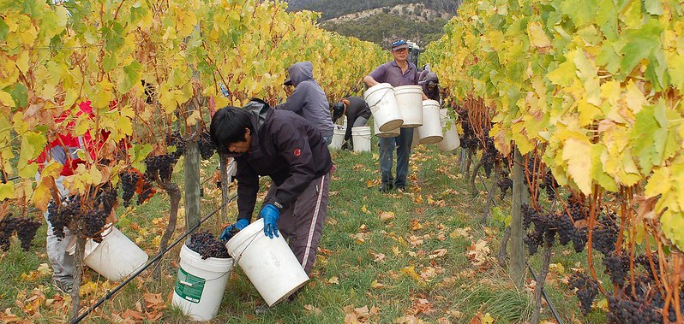

**Keeping our Agricultural Economy Strong. *Expanding Testing to Contain COVID***

In San Joaquin County, agriculture is an essential part of our economy and our way of life.

San Joaquin County Clinics and the Agricultural Commissioner has joined hands to minimize the negative impact of COVID on our agricultural community. Our goal is to keep our agricultural industry thriving and the workforce COVID-free. By testing and identifying people who are coronavirus carriers, we can quickly take steps to isolate them while the virus is active and mitigate the spread.

San Joaquin County Clinics has expanded testing to benefit our agricultural workers. We are providing this at no cost to the worker nor the employer. We will provide a complete service, from testing to assisting persons who test positive in accessing resources available to them.

We would like to bring these services to your company.

* We will work with you on logistics. We are very nimble. The medical team will come to your worksite bringing all equipment and supplies in a van and set up a pop-up coronavirus testing clinic.
* Results of the tests are usually out in 3-4 days. Public Health processes all specimens collected.
* Persons who test will be notified of the results. We will ask employees to sign a release of information form at the time of the testing, which would allow us to share results with the employer.
* Your employees who test positive will be offered support from Housing for the Harvest which includes isolation accommodation, meals and other services during the time that they have an active virus.
  + While in isolation, San Joaquin County Clinics will provide medical monitoring for them.
  + At the end of their isolation period, Public Health will issue them a "clearance from isolation" documentation that verifies their readiness to go back to work.
* These services are made possible through our collaboration San Joaquin County Public Health Services, Housing for the Harvest, Community Foundation of San Joaquin and Catholic Charities.

Let’s work together in keeping your employees healthy and COVID free.

**For more information or to arrange a pop-up clinic, contact:  
Joan Singson**

**San Joaquin County Clinics**

**Business: (209) 468-7856**

**Mobile: (209) 406-4645**

[**jsingson@sjgh.org**](mailto:jsingson@sjgh.org)